EDA - F1 Clustering Project
Roee Amsalem, Oren Yehezkel, Ido Brener

1 Basic information about the dataset:

An important comment before we start:
In this document we would refrence to two different datasets:
- Raw data – in this dataset, each row is a sample, taken from a F1 car during a certain race using the sensors that are installed on the car. This data is directly imported from the API of the OpenF1 project, and it is the base of the second dataset, on which we plan to do the clustering.
- Processed data – in this dataset, each row is a turn a driver made during the race, the columns of this dataset are made using feature engineering. This dataset is the one we would do the clustering on.

- Dataset name: F1 Driver Cornering Telemetry (Custom Built Dataset)
- Data origin: Live telemetry of F1 cars from 4 official events that happened during 2023: Monza, Singapore, Spa, Suzuka. The information was extracted using OpenF1 project’s API.
- Number of samples: Raw data – 28086, Processed data - 1109
- Number of identifiers: Raw data – 2, Processed data - 3
- Number of features: Raw data – 10, Processed data - 12
- The Domain: The data comes from sensor measurments installed on each F1 car, that measure the telemetry data of the car at 3.7Hz (almost 4 times a second).

2 Feature Understanding:

Raw data:
The rows of the dataset: Each row is a sample taken in a certain time during the fastest lap of each driver in a qualifying round during one of the 4 races.
Indentifiers:
- track – the name of the track
  - Units: irrelevant.
  - Possible value range: {Monza, Singapore, Spa, Suzuka}.
- driver_number – a unique identifier given to every F1 driver.
  - Units: ireelevant.
  - Possible value range: {1, 2, 3, 4, 10, 11, 14, 16, 18, 20, 22, 23, 24, 27, 31, 40, 44, 55, 63, 77, 81}.
Features:
- lap_duration – the time needed to do the lap
  - Units: seconds
  - Possible value range: 0-130 seconds
- x – the drivers position in the x axis.
  - Units: irrelevant.
  - Possible value range: -15000 - 15000
- y – the drivers position in the y axis.
  - Units: irrelevant.
  - Possible value range: -20000 - 20000
- speed – the speed of the car.
  - Units: km/h
  - Possible value range: 0-400 km/h.
- brake – wether the brake pedal is pressed or not.
  - Units: irrelevant.
  - Possible value range: {0,100}
- throttle – the throttle position precentage.
  - Units: irrelevant.
  - Possible value range: 0-100
- n_gear – the current gear of the car
  - Units: irrelevant
  - Possible value range: 0-8.
- rpm – the amount of rounds per minute the car engine is doing.
  - Units: number of rounds.
  - Possible value range: 0-14000 rounds.

Processed data:
The rows of the dataset: Each row in the dataset represents a turn that a certain driver made during his fastest lap in a certain event.
The dataset columns:
Indentifiers:
- track – the name of the track
  - Units: irrelevant.
  - Possible value range: {Monza, Singapore, Spa, Suzuka}.
- global_corner_id – a unique identifier given to every corner during the corner detection process.
  - Units: ireelevant.
  - Possible value range: {101-110, 201-216, 301-316, 401-416}.
- driver_number – a unique identifier given to every F1 driver.
  - Units: ireelevant.
  - Possible value range: {1, 2, 3, 4, 10, 11, 14, 16, 18, 20, 22, 23, 24, 27, 31, 40, 44, 55, 63, 77, 81}.
Features:
- entry_speed – the speed of the car in the start of the turn.
  - Units: km/h
  - Possible value range: 0-400 km/h
- apex_speed – the minimal speed of the car during the turn.
  - Units: km/h
  - Possible value range: 0-400 km/h
- exit_speed – the speed of the car in the end of the turn.
  - Units: km/h
  - Possible value range: 0-400 km/h
- speed_drop – the difference between “entry_speed” to “apex_speed”.
  - Units: km/h
  - Possible value range: 0-400 km/h.
- braking_pct_before_apex – the precentage of the segment of the turn that is before the apex in which the driver presses on the brake pedal
  - Units: precentage.
  - Possible value range: 0-1.
- trail_braking_pct – the precentage of the turn in which the driver performed “trail breaking” (a slow release of the brake pedal).
  - Units: precentage.
  - Possible value range: 0-1.
- throttle_app_pct_after_apex – the precentage of the segment of the turn that is after the apex in which the driver presses on the throttle.
  - Units: precentage.
  - Possible value range: 0-1.
- coasting_pct – the precentage of the turn in which the driver didn’t press on the brake nor the throttle.
  - Units: precentage.
  - Possible value range: 0-1.
- breaking_time_pct – the precentage of the turn in which the driver pressed the brake pedal.
  - Units: precentage.
  - Possible value range: 0-1.
- min_gear – the minimal gear that the car was on during the turn.
  - Units: irrelevant
  - Possible value range: 0-8.
- avg_throttle – The average percentage the throttle pedal is pressed during the turn.
  - Units: precentage.
  - Possible value range: 0-100.
- avg_speed – The average speed of the car during the turn.
  - Units: km/h
  - Possible value range – 0-400 km/h.

Difference in feature scale:
We must notice there is a big difference in scale between the features that are speed-based, which are measured in km/h and are between 0-400, and the features that are braking/throttle-based, which are measured in precentages between 0-1. There will be a process of normalization of the features to the 0-1 range, in order to make sure that no feature has dramatic influence over the outcome of the clustering process.

3 Missing Values:

Our data is imported through the API of the project “OpenF1”, that aims to make official data from races accecible to the public for research purposes. In addition to making the data accesible, the project already filters any missing value caused by technical issues like damaged sensors. Therfore, we cannot calculate the precentage of missing values from the entire dataset.

Although the data was already “cleaned” from technical missing values, it has obvious theoretical missing values that may impact how well the data reflects the reality of an actual F1 race:
- There are approximatly 0.25 seconds between samples (the sample rate is 3.7Hz), in which, assuming the driver drives at an average of 200 km/h, the driver covers around 15 meters, that can be vital to learning his behavior during a turn.
- In the start and end point of each lap there is a gap of a few seconds in which the sensors of the cars stop producing new data. This gap can register as a turn when using our calculations, that relay on the change in location of the driver, thus generating noise that can affect the clustering.

These missing values may make it harder for us to understand the real-life implications of our clustering results on the drivers’ driving style, but it is unlikely because of the huge amount of data that is gathered.

4 Outliers and Data Quality:

Raw data:
Statistics:
Feature_Name | Minimum | Maximum | Mean | Median | Standard_Deviation
speed | 50 | 350 | 223.9458 | 234 | 74.5259
n_gear | 2 | 8 | 5.7148 | 6 | 1.9139
throttle | 0 | 100 | 71.7619 | 99 | 40.0555
brake | 0 | 100 | 16.3874 | 0 | 37.0168
x | -13708 | 11068 | -1043.9124 | -416 | 5947.2782
y | -15771 | 15883 | -1005.0467 | -616 | 7179.7117

Analysis:
After using box plots to analyze the data, we have reached a few conclusions:
- There are no impossible values in our data, simply because they are bounded by physics, for example, we didn’t see any negtive speed or gear number, simply because they don’t exist.
- There are a lot of measurement errors that may happen because of a faulty sensor or because of the cross between two different laps.
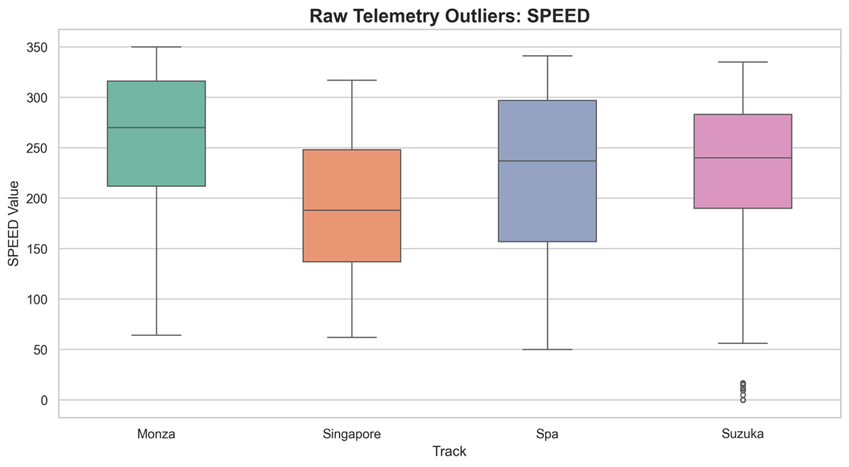
- There are almost no extreme outliers, and those that exist are mostly the measurements errors, we can look for example on the box plot for the speed of the drivers:

Since this is not the data we perform the clustering on, and considering we filter the data while processing it, these outliers and measurement errors will not affect the clustering process.

Processed data:
Statistics:
Feature_Name | Minimum | Maximum | Mean | Median | Standard_Deviation
entry_speed | 64 | 335 | 199.7502 | 203 | 4348.4204
apex_speed | 50 | 320 | 162.8539 | 152 | 4779.5581
exit_speed | 52 | 320 | 179.7773 | 179 | 4883.9458
speed_drop | 0 | 178 | 36.8963 | 27 | 1467.3439
braking_pct_before_apex | 0 | 1 | 0.3717 | 0.4245 | 0.1122
trail_braking_pct | 0 | 1 | 0.3303 | 0.3062 | 0.108
throttle_app_pct_after_apex | 0 | 1 | 0.7615 | 1 | 0.1244
coasting_pct | 0 | 0.815 | 0.096 | 0 | 0.0184
braking_time_pct | 0 | 1 | 0.2614 | 0.25 | 0.0662
average_throttle | 0 | 100 | 47.3506 | 40.6154 | 1198.2503
min_gear | 2 | 8 | 4.3607 | 4 | 2.7687
average_speed | 60.3077 | 321.5714 | 178.9551 | 176 | 4389.51

Analysis:
After using box plots to analyze the data, we have reached fascinating conclusions:
- There are no impossible values in our data, simply because they are bounded by physics, for example, we didn’t see any negtive speed or gear number, simply because they don’t exist.
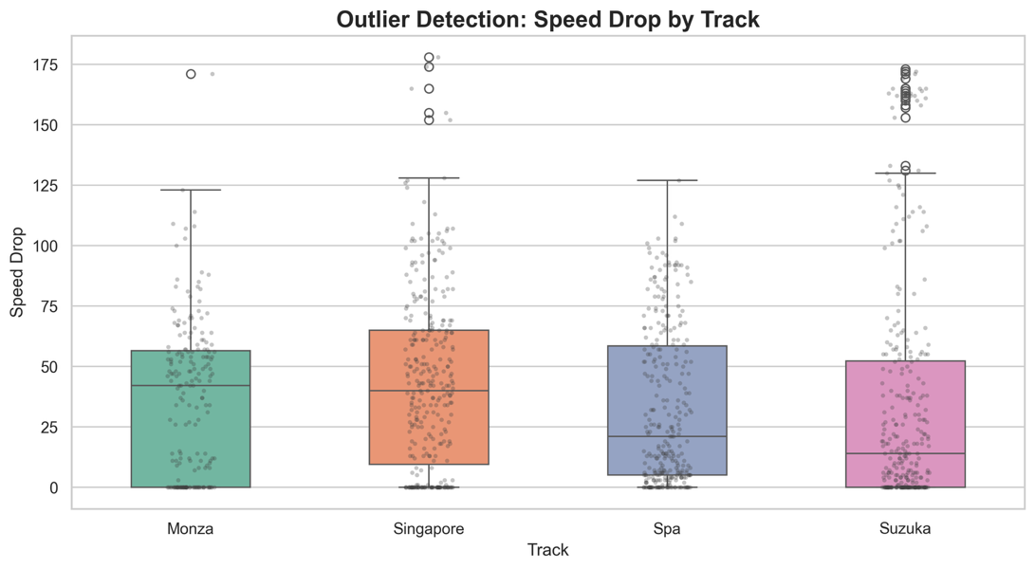
- There are many extreme outliers in almost every parameter, for example, let’s look at the box plot for the speed drop:
We can see that in almost every race, there are extreme oultiers.
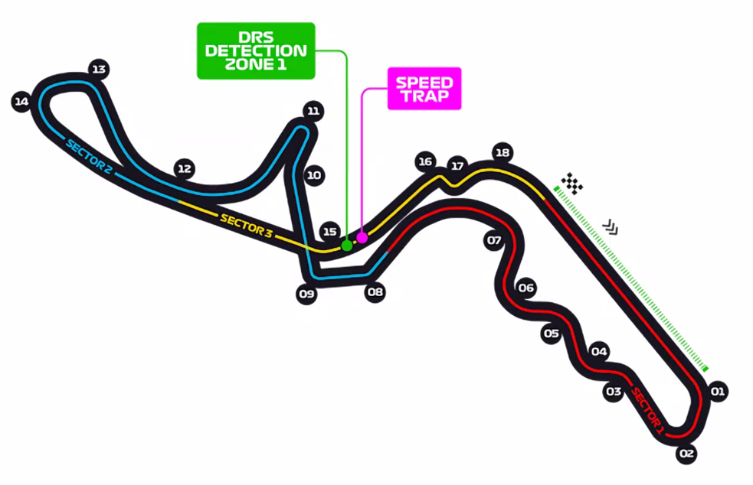
This reason for this massive amount of outliers and extreme outliers, is the difference between the turns themselves. For example, in Suzuka, there is one specific turn, marked 11 on the following map, that forces driver to decelerate extremely in order to succeed it.
This turn explains the massive amount of outliers in terms of speed drop, there are only 20 samples, one from each driver in this racetrack, that require such a massive speed drop.

Those extreme outliers would draw the center of the clusters towards them and by that affect the clustering process. We may need to normalize the data differently.

5 Data Visualization:

Raw Data:
Feature distrubution:
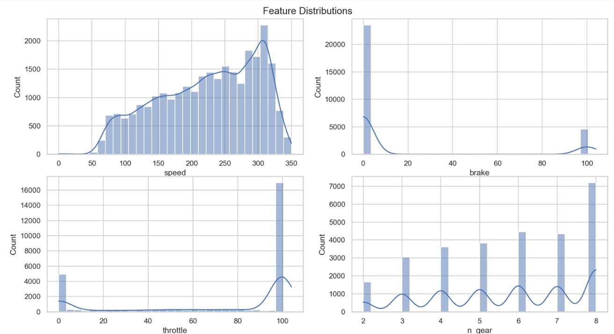
Relationships between features:
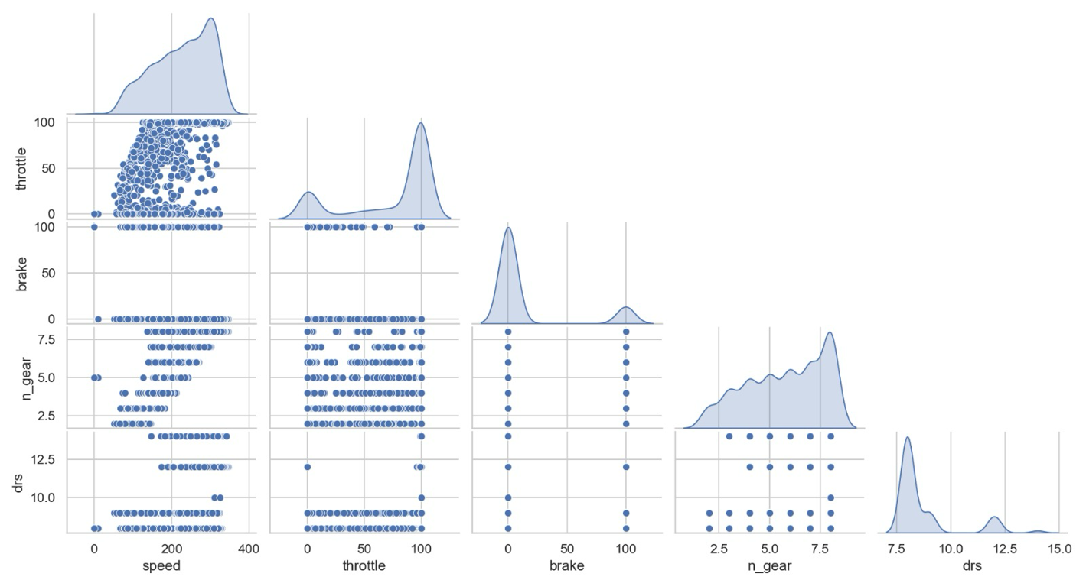

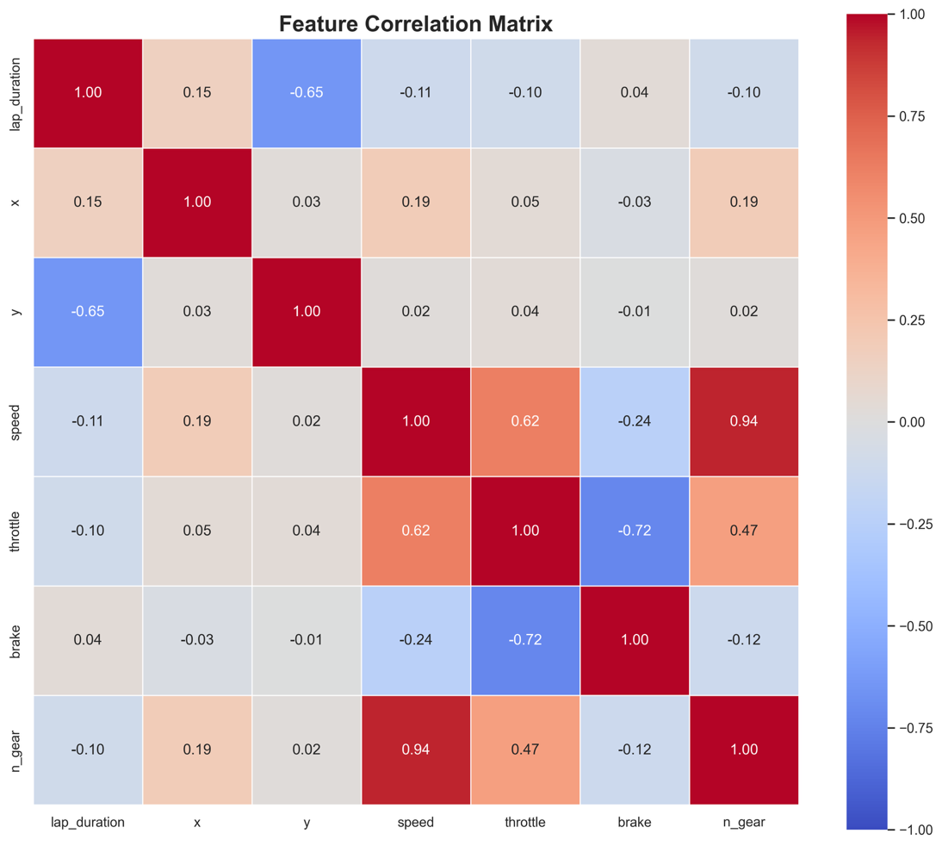
Feature Correlation Matrix Heatmap:

Processed data:
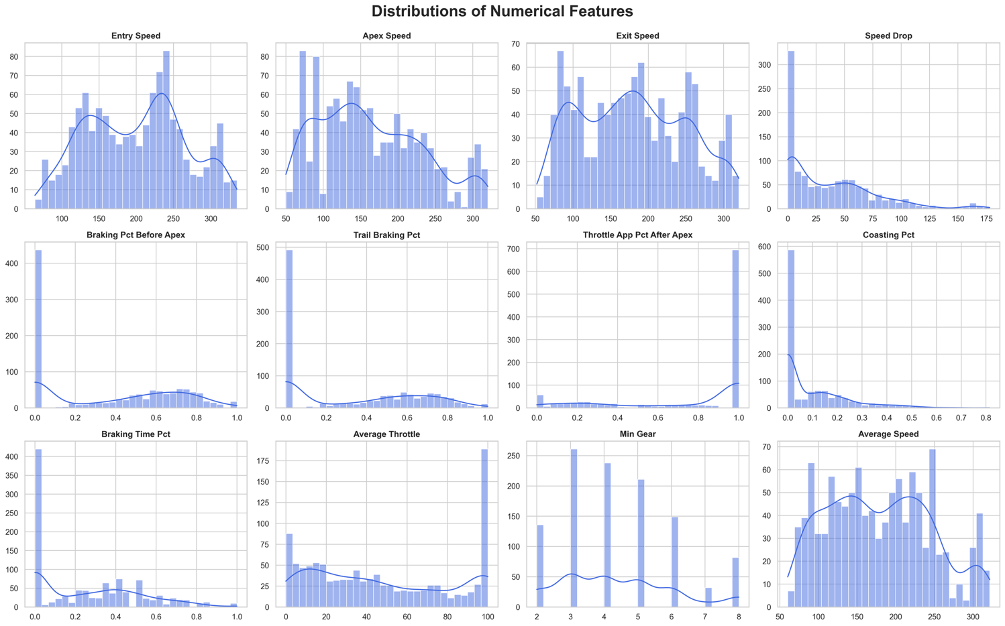
Feature distrubution:

Differences between categories – differences between the different races:
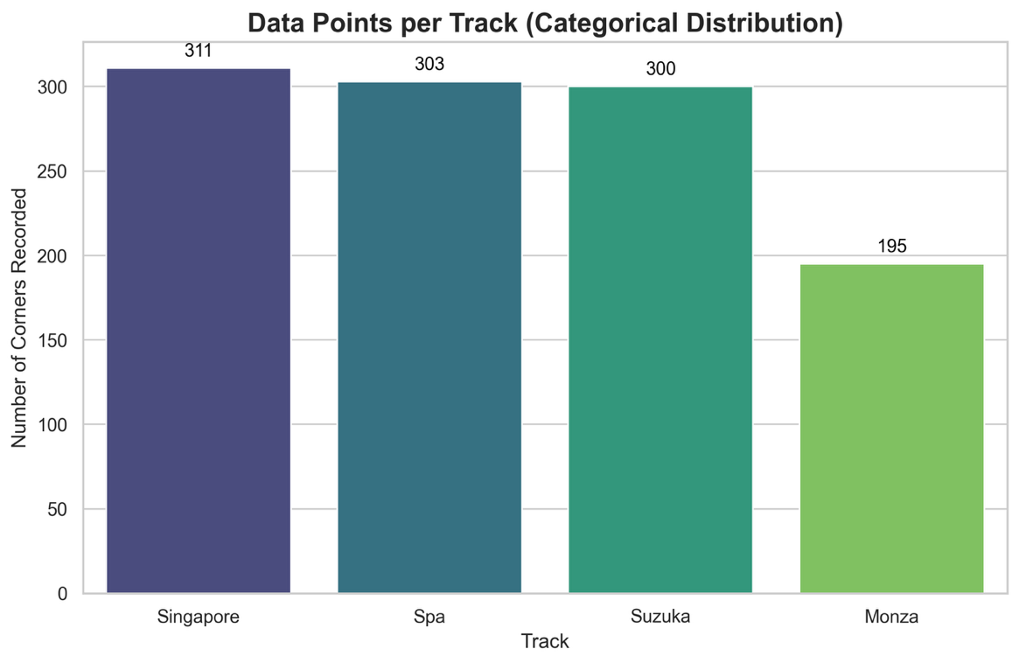
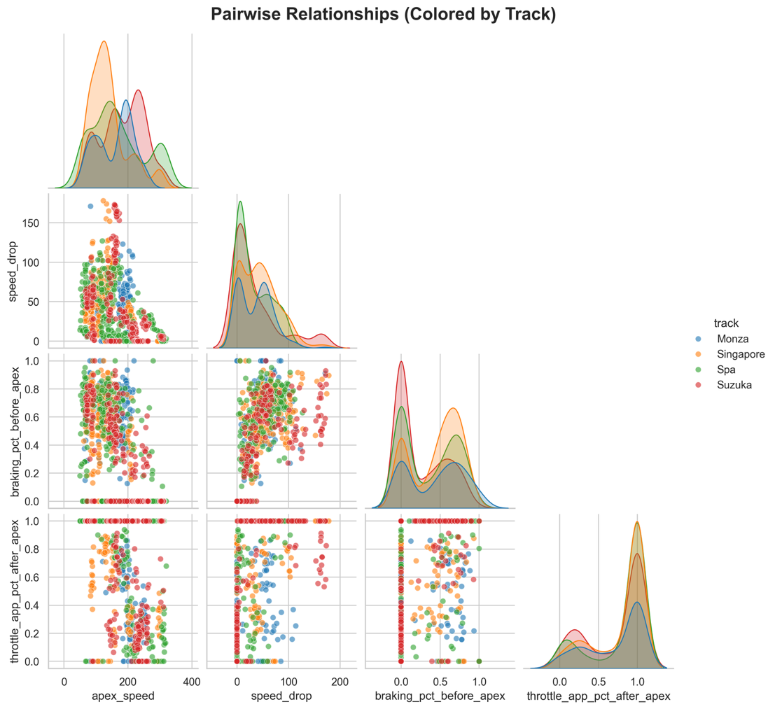
Relationships between features:

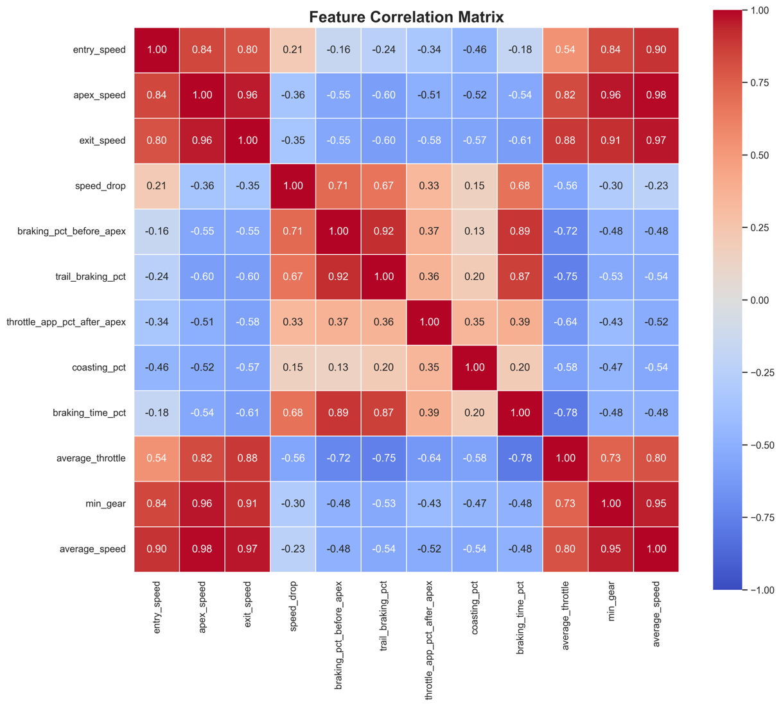
Feature Correlation Matrix Heatmap:

6 Feature Engineering:

Creating new features from existing data:
Based on the raw data, we have done a process of feature engineering in order to make the second dataset. This processs is made of a few steps:
- Corner detection using a geometric algorithm.
- Classifying samples in time as “corner” or “not corner”
- Filtering only the relevant data marked as “corner”.
- Calculating different features using the filtered data.
Finally, after this process, the feature engineered features are:
- global_corner_id – given to each group of points that belong to the same corner using the geometric algorithm we used.
- entry_speed – taking the first speed measurment classified as “corner” in each turn of each driver.
- apex_speed – taking the minimal speed in every group of points classified as “corner” of each driver.
- exit_speed – taking the last speed measurment classified as “corner” in each turn of each driver.
- speed_drop – the difference between “entry_speed” to “apex_speed”.
- braking_pct_before_apex – calculating the precentage of the measurments before the apex point that had brake = 100 (brake is boolean) in them out of all the measurments before the apex point.
- trail_braking_pct – calculating the precentage of the measurments before the apex point that had brake = 100 (brake is boolean) and throttle < 5% in them out of all the measurments before the apex point.
- throttle_app_pct_after_apex – calculating the precentage of the measurements after the apex point that had throttle > 0 out of all the measurements.
- coasting_pct – calculating the precentage of the measurments before the apex point that had
brake = 0 and throttle < 10% in them out of all the measurments before the apex point.
- breaking_time_pct – calculating the precentage of the measurments that belong to the turn in which brake = 100 (break is boolean) out of all the measurmens that belong to the turn.
- min_gear – taking the minimal n_gear of the turn’s measurments.
- avg_throttle – calculating the average use of throttle across all measurments that belong to the turn.
- avg_speed – calculating the average speed across all measurments that belong to the turn.

Considering feature transformations:
Since distance-based clustering algorithms (K-Means) are highly sensitive to variable scales, standardization (Z-score scaling) is required. Without it, absolute features like entry_speed (up to 330 km/h) would completely dominate relative behavioral features like braking_time_pct (0 to 1). We will apply standardization so every feature contributes equally to the distance metrics.

Perform feature selection:
Before training the model, identifier columns such as track, global_corner_id, and driver_number will be excluded from the dataset, as they do not represent driving behavior (they will only be used later for analyzing the resulting clusters).

We engineered multiple speed metrics (entry_speed, apex_speed, exit_speed, speed_drop). Including all of them would provide highly overlapping information, forcing the algorithm to “double-count” speed over driving technique. We will prioritize derived behavioral metrics (like speed_drop and percentages) over speed metrics.

Reduce Dimensionality: We have already performed massive dimensionality reduction during the feature engineering phase—compressing 28,086 rows of raw time-series sensor data into just 1,109 fixed “corner profiles” with 12 features. With such a concise feature space, applying PCA is unnecessary.

Evaluating how engineered structures will affect clustering structure, distances between samples and model performance:
Clustering structure:
Before Feature Engineering : If we applied clustering directly to the raw telemetry data (individual timestamps of speed, throttle, x/y coordinates), the clustering structure would merely capture the physical layout of the tracks. The model would group all “straight lines” together and all “slow corners” together, completely missing the driver's behavioral traits.

After Feature Engineering : By engineering features that represent an entire corner sequence (e.g., braking_pct_before_apex, trail_braking_pct, speed_drop), we transformed the clustering space from geographical to behavioral. The structure now naturally groups samples by driving style (e.g., aggressive late-brakers vs. smooth drivers who carry speed into the apex) regardless of which physical corner on which track they are driving.

Distances between samples:
Raw Data: Distance metrics on raw data are heavily skewed by absolute values. A sample taken in Monza at 320 km/h and a sample in Singapore at 150 km/h would have a huge distance, simply because of the track's nature.

Engineered Features: Our engineered features act as a great equalizer. By translating raw inputs into ratios and percentages (like coasting_pct or braking_time_pct), distance metrics now calculate the similarity in the technique applied during the corner. A small distance between two samples now implies a highly similar cornering profile (similar aggressiveness), making the distance metric actually meaningful for our research question.

Downstream model performance:
Clustering algorithms cannot easily handle variable-length time series (a corner taken at low speed has more raw data points than a fast corner). By aggregating the time-series points of a single corner into one row of fixed features (reducing the dataset from 28,086 rows to 1,109 rows), we solved the dimensionality issue.

This significantly reduces the algorithm's running time, prevents the “curse of dimensionality”, and ensures the algorithm can successfully converge into meaningful clusters of mild vs. aggressive driving styles, which would have been impossible with the raw data.

7 Unbalanced Data:

Since our project focuses on unsupervised learning (Clustering), we do not have predefined “classes” (like spam vs. non-spam). However, we carefully evaluated dataset imbalance regarding drivers, tracks, and corner characteristics:
- Driver Representation (Balanced):
By intentionally extracting only the single fastest lap for each driver during the Qualifying sessions, we successfully prevented driver imbalance. No single driver dominates the dataset with more laps than others (due to advancing to Q3 vs. Q1 elimination). This ensures a fair representation of all drivers.
- Track Representation (Unbalanced):
While the drivers are equally represented, the tracks are not. Our dataset is built on corner-by-corner analysis, and the number of physical corners varies significantly between tracks. For example, Singapore is a complex track with 13 corners, while Monza, a high-speed track, has only 8 corners. Therfore, our processed dataset contains significantly more samples (rows) originating from tracks like Singapore and Spa compared to Monza.
- ⁠Corner Type Representation (Speed Profile Imbalance)
Another imbalance is the the corners themselves. The distribution of corner types across the selected tracks not uniform. If our dataset consists of a majority of low-speed corners, the clustering algorithm might simply separate the data into “slow corners” and “fast corners” based on speed values, completely missing the underlying “driver behavior styles”.
- ⁠Understanding Implications & Preprocessing Considerations:
Distance-based clustering algorithms (like K-Means) calculate centroids based on data density. If Singapore (or slow corners in general) accounts for a much larger portion of our dataset, the resulting clusters might be heavily biased towards “Street Circuit Driving Styles” (heavy braking, low speeds), masking the traits of high-speed corners.
Action Plan: To make sure the model evaluates driver technique rather than corner physics, perform Standardization on a per-corner basis. By calculating scores relative to each specific global_corner_id, we force the model to look at how a driver performed relative to the baseline of that exact corner. This neutralizes the corner's absolute speed and prevents tracks with a high corner count from dominating the global clustering model.

8 Final Documentation:

Main Observations about the Dataset:
During the Exploratory Data Analysis (EDA) of the telemetry and driving style data, several critical observations emerged that shaped our understanding of the dataset:

Unique Driving Signatures vs. Track Constraints: The data clearly shows that each driver possesses a dynamic “fingerprint” (for example, a tendency to brake late or coast). However, we discovered that the physical layout of the circuit (Track Bias) exerts a much stronger influence than the differences in individual driving styles. For example, the average Entry Speed at Monza is tens of km/h higher than at a street circuit like Singapore. This proved that clustering raw data would result in grouping by track rather than by driver.

Physical Significance of Outliers: We identified a significant presence of outliers, particularly in features like Coasting_Pct (percentage of time spent coasting without pedal application) and Trail_Braking_Pct. Unlike financial datasets where anomalies are often data-entry errors, in Formula 1 telemetry, these outliers are authentic records. They represent genuine driving mistakes (such as lock-ups on tight tracks) or highly aggressive driving techniques (for example 15% coasting in a corner where the grid average is 0%).

Feature Correlation and Redundancy: The Correlation Heatmap revealed high correlations (often > 0.8) between certain features, such as braking distance and braking time. This highlighted the absolute necessity of Feature Engineering to consolidate overlapping metrics into a normalized “aggressiveness” score. Without this, a K-Means algorithm would inadvertently assign double weight to a single physical characteristic represented across multiple columns.

Important Preprocessing Considerations
The data preprocessing phase required several fundamental engineering decisions to adapt continuous telemetry data for an unsupervised machine learning algorithm. The core considerations were as follows:

Strategic Data Selection & Context: To ensure the model compares drivers when they are operating at absolute peak performance (Limit Handling) and under identical conditions, we chose to isolate the data to Qualifying sessions only, specifically extracting the single fastest lap per driver per track. This crucial decision neutralizes numerous confounding variables inherent to race conditions (such as fuel saving, tire degradation management, “dirty air” from leading cars, and overtaking tactics), leaving us with a pure representation of the driver's and car's maximum limits.

Sanitizing Sensor Glitches (Data Quality): High-frequency telemetry data naturally suffers from measurement noise. During our EDA, we found phantom readings such as throttle applications registering at 104%, speeds of zero mid-lap, or sudden drops to neutral gear. We applied a physics-based logical cleaning mechanism: pedal inputs were clipped to a maximum of 100%, and rows containing physically impossible RPM or speed readings for a competitive flying lap were filtered out.

Strategic Handling of Outliers: As noted in our observations, we decided against applying aggressive outlier removal techniques (such as hard clipping, Winsorization, or dropping rows outside the IQR). Doing so would have erased the exact nuances that separate a smooth driving style from an erratic or aggressive one. Instead, extreme values were retained and managed during the scaling phase using robust methodologies.

Context-Aware Scaling (The “Per-Corner” Method): This was the pivotal engineering decision of the project. Because K-Means relies on Euclidean distance, leaving data in its original scales (km/h vs. percentages) would severely distort the model. To solve both the scale disparity and the aforementioned “Track Bias”, we implemented Group-wise Z-Score Scaling (Per-Corner Scaling).
Instead of normalizing a feature (like braking percentage) against the overall season average, we normalized it against the mean and standard deviation of all drivers in that specific corner on that specific track. This technique successfully zeroed out the influence of the track layout, allowing us to feed multiple diverse tracks into a single model. What remained was pure “delta” — the specific driver's deviation from the group norm at that exact geographical coordinate.

Work process:
Oren - 1,2,4,5,6
Ido - 3,4,5,6,8
Roee - 3,6,7,8

